Test Report

First Test-March 15th

Unit Test1

Basic test-corresponding to a single timestamp
Test Input
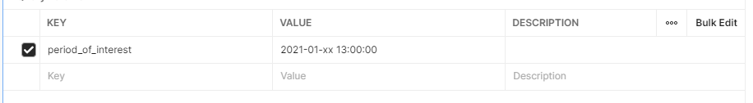

output

{
"log": {
"team": "SENG3011_LINKED_LIST",
"time_accessed": "2021-03-17T11:53:30.600Z"
},
"articles": [
{
"id": "g67edVI2X90bWQ4yUSJ7",
"headline": "Novel Coronavirus - Japan (ex-China)",
"main_text": "On 15 January 2020, the Ministry of Health, Labour and Welfare, Japan (MHLW) reported an imported case of laboratory-confirmed 2019-novel coronavirus (2019-nCoV) from Wuhan, Hubei Province, China. The case-patient is male, between the age of 30-39 years, living in Japan. The case-patient travelled to Wuhan, China in late December and developed fever on 3 January 2020 while staying in Wuhan. He did not visit the Huanan Seafood Wholesale Market or any other live animal markets in Wuhan. He has indicated that he was in close contact with a person with pneumonia. On 6 January, he traveled back to Japan and tested negative for influenza when he visited a local clinic on the same day.",
"reports": [
{
"id": "eWNmTwDbDmE396xk7sV6",
"diseases": [
"2019-nCoV"
],
"event_date": "2020-01-02T13:00:00.000Z",
"syndromes": [
"Fever of unknown Origin"
],
"locations": []
}
],
"date_of_publication": "2021-01-16T13:00:00.000Z",
"url": "https://www.who.int/csr/don/17-january-2020-novel-coronavirus-japan-ex-chila/en/"
}
]
}

Success

Unit Test2

Corresponding to two timestamps
Test Input
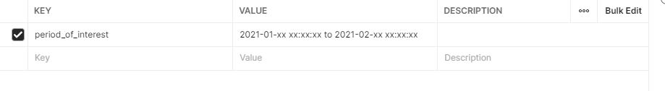

Test output

{
"errorMessage": "400 'start_date' is an invalid date format"
}
fail

Unit Test3

Corresponds to 1 precise time
Test Input
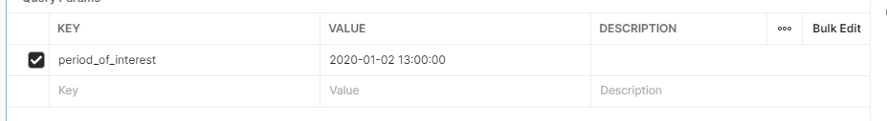

Test output
{
"errorMessage": "400 '2020-01-02 13:00:00 does not contain any wildcards"
}

fail

Unit Test4

Corresponding to 2 precise time (WTF, I did not fill in the hour)
Test Input
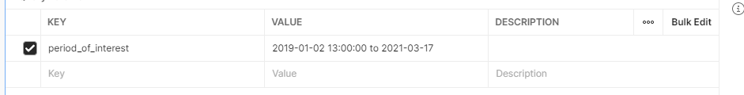
Test output
{
"log": {
"team": "SENG3011_LINKED_LIST",
"time_accessed": "2021-03-17T11:58:05.481Z"
},
"articles": [
{
"id": "g67edVI2X90bWQ4yUSJ7",
"headline": "Novel Coronavirus - Japan (ex-China)",
"date_of_publication": "2021-01-16T13:00:00.000Z",
"url": "https://www.who.int/csr/don/17-january-2020-novel-coronavirus-japan-ex-chila/en/",
"main_text": "On 15 January 2020, the Ministry of Health, Labour and Welfare, Japan (MHLW) reported an imported case of laboratory-confirmed 2019-novel coronavirus (2019-nCoV) from Wuhan, Hubei Province, China. The case-patient is male, between the age of 30-39 years, living in Japan. The case-patient travelled to Wuhan, China in late December and developed fever on 3 January 2020 while staying in Wuhan. He did not visit the Huanan Seafood Wholesale Market or any other live animal markets in Wuhan. He has indicated that he was in close contact with a person with pneumonia. On 6 January, he traveled back to Japan and tested negative for influenza when he visited a local clinic on the same day.",
"reports": [
{
"id": "eWNmTwDbDmE396xk7sV6",
"syndromes": [
"Fever of unknown Origin"
],
"event_date": "2020-01-02T13:00:00.000Z",
"locations": [],
"diseases": [
"2019-nCoV"
]
}
]
},
{
"id": "13",
"report": [],
"maintext": " New Travel RequirementsAll air passengers coming to the United States, including U.S. citizens, are required to have a negative COVID-19 test result or documentation of recovery from COVID-19 before they board a flight to the United States. See the Frequently Asked Questions for more information.Masks are required on planes, buses, trains, and other forms of public transportation traveling into, within, or out of the United States and in U.S. transportation hubs such as airports and bus or rail stations.Level 3: High Level of COVID-19 in JapanKey Information for Travelers to JapanTravel increases your chances of getting and spreading COVID-19. CDC recommends that you do not travel at this time.Travelers should avoid all nonessential travel to Japan.Travelers at increased risk for severe illness from COVID-19 should avoid all travel to Japan.If you must travel: Before you travel, get tested with a viral test 1–3 days before your trip. Do NOT travel if you were exposed to COVID-19, you are sick, or you test positive for COVID-19. Learn when it is safe for you to travel. Don't travel with someone who is sick.Follow all entry requirements for your destination and provide any required or requested health information.If you do not follow your destination's requirements, you may be denied entry and required to return to the United States.During travel, wear a mask, avoid crowds, stay at least 6 feet from people who are not traveling with you, wash your hands often or use hand sanitizer, and watch for symptoms. Before traveling back to the United States by air, get tested with a viral test no more than 3 days before your flight departs. The test result must be negative. Keep a copy of your test results with you during travel in case you are asked for them. See Frequently Asked Questions for more information about this requirement. Follow all destination and airline recommendations or requirements.After you travel, get tested 3–5 days after travel AND stay home to self-quarantine for 7 days after travel. If you don't get tested, it's safest to stay home to self-quarantine for 10 days. COVID-19 Levels Level 4: Very High Level 3: High Level 2: Moderate Level 1: Low Level unknownLearn more about COVID-19 levels.See all COVID-19 travel notices.Travel and COVID-19Travel increases your chance of getting and spreading COVID-19. Stay home to protect yourself and others from COVID-19. Airports, bus stations, train stations, and rest stops are all places travelers can be exposed to the virus. These are also places where it can be hard to social distance. If you travel, take steps before, during, and after travel to keep yourself and others from getting COVID-19.Before You TravelTalk to your doctor ahead of travel, especially if you are at increased risk for severe illness from COVID-19.If you are eligible, get fully vaccinated for COVID-19. Wait 2 weeks after getting your second vaccine dose to travel—it takes time for your body to build protection after any vaccination.Get tested with a viral test 1–3 days before your trip.Do NOT travel if you were exposed to COVID-19, you are sick, or you test positive for COVID-19. Learn when it is safe for you to travel. Don’t travel with someone who is sick.If traveling by air, check if your airline requires any health information, test results, or other documents. Check with your destination's Office of Foreign Affairs or Ministry of Health or the US Department of State, Bureau of Consular Affairs, Country Information page for details about entry requirements and restrictions for arriving travelers. Follow any entry requirements or restrictions at your destination which might include testing, quarantine, and providing contact information. If you do not follow your destination's requirements, you may be denied entry and required to return to the United States. If you test positive on arrival, you might be required to isolate. You might be prevented from returning to the United States as scheduled. If you get sick in Japan, you might need medical care. Plan ahead and learn more about Getting Health Care During Travel.During TravelIf you must travel, take the following steps to protect yourself and others from COVID-19:Wear a mask over your nose and mouth when in public settings. Masks are required on planes, buses, trains, and other forms of public transportation traveling into, within, or out of the United States and in U.S. transportation hubs such as airports and stations.Avoid crowds and stay at least 6 feet/2 meters (about 2 arm lengths) from anyone who did not travel with you. It's important to do this everywhere—both indoors and outdoors.Wash your hands often or use hand sanitizer (with at least 60% alcohol).Bring extra supplies, such as masks and hand sanitizer.Avoid contact with anyone who is sick.Avoid touching your eyes, nose, and mouth.Before traveling back to the United States by air, get tested with a viral test no more than 3 days before your flight departs. The test result must be negative. Keep a copy of your test results with you during travel in case you are asked for them. See Frequently Asked Questions for more information about this requirement. Follow all destination and airline recommendations or requirements.After You TravelYou may have been exposed to COVID-19 on your travels. You may feel well and not have any symptoms, but you can still spread the virus to others. You and your travel companions (including children) may pose a risk to your family, friends, and community after your travel.Get Tested and Stay Home After TravelGet tested with a viral test 3–5 days after travel AND stay home to self-quarantine for a full 7 days after travel. Even if you test negative, stay home to self-quarantine for the full 7 days.If your test is positive, isolate yourself to protect others from getting infected.If you don't get tested, it's safest to stay home for 10 days after travel.Avoid being around people who are at increased risk for severe illness for 14 days, whether you get tested or not.Follow state and local recommendations or requirements after travel. Also, take these actions after you return from travel to protect others from getting COVID-19:Avoid crowds and stay at least 6 feet/2 meters (about 2 arm lengths) from anyone who did not travel with you. It’s important to do this everywhere — both indoors and outdoors. Wear a mask over your nose and mouth when in public settings. Masks are required on planes, buses, trains, and other forms of public transportation traveling into, within, or out of the United States and in U.S. transportation hubs such as airports and stations.If there are people in the household who did not travel with you, wear a mask and ask everyone in the household to wear masks in shared spaces inside your home for 14 days after travel. Wash your hands often or use hand sanitizer with at least 60% alcohol.Avoid being around people who are at increased risk for severe illness.Watch your health: Look for symptoms of COVID-19.See CDC's After You Travel page for more information.Other ConsiderationsIf you get sick with COVID-19 or test positive for the virus that causes COVID-19 while abroad, you might not be permitted to return to the United States until you can end isolation. If you are exposed to someone with COVID-19 during travel, you might be quarantined and not be permitted to return to the United States until your quarantine is lifted.Clinician InformationClinicians should obtain a detailed travel history for patients with symptoms of COVID-19 infection. If you suspect that a traveler has COVID-19, see Information for Healthcare Professionals about Coronavirus (COVID-19) for information on evaluating, reporting, clinical care guidance, and infection control.Additional InformationKnow When Not to Travel to Avoid Spreading COVID-19How CDC Determines the Level of a Destination’s COVID-19 Travel Health NoticeTravel During COVID-19Testing and International Air TravelCoronavirus Disease 2019Information for Healthcare ProfessionalsWHO, CoronavirusUS Department of State: Smart Traveler Enrollment Program (STEP) , All air passengers coming to the United States, including U.S. citizens, are required to have a negative COVID-19 test result or documentation of recovery from COVID-19 before they board a flight to the United States. See the Frequently Asked Questions for more information., Masks are required on planes, buses, trains, and other forms of public transportation traveling into, within, or out of the United States and in U.S. transportation hubs such as airports and bus or rail stations., , Level 4: Very High, , Level 3: High, , Level 2: Moderate, , Level 1: Low, , Level unknown, Learn more about COVID-19 levels., See all COVID-19 travel notices., Travel increases your chance of getting and spreading COVID-19. Stay home to protect yourself and others from COVID-19. Airports, bus stations, train stations, and rest stops are all places travelers can be exposed to the virus. These are also places where it can be hard to social distance. If you travel, take steps before, during, and after travel to keep yourself and others from getting COVID-19., , Talk to your doctor ahead of travel, especially if you are at increased risk for severe illness from COVID-19., If you are eligible, get fully vaccinated for COVID-19. Wait 2 weeks after getting your second vaccine dose to travel—it takes time for your body to build protection after any vaccination., Get tested with a viral test 1–3 days before your trip., Do NOT travel if you were exposed to COVID-19, you are sick, or you test positive for COVID-19. Learn when it is safe for you to travel. Don’t travel with someone who is sick., If traveling by air, check if your airline requires any health information, test results, or other documents. Check with your destination's Office of Foreign Affairs or Ministry of Health or the US Department of State, Bureau of Consular Affairs, Country Information page for details about entry requirements and restrictions for arriving travelers. Follow any entry requirements or restrictions at your destination which might include testing, quarantine, and providing contact information. If you do not follow your destination's requirements, you may be denied entry and required to return to the United States. If you test positive on arrival, you might be required to isolate. You might be prevented from returning to the United States as scheduled. , If you get sick in Japan, you might need medical care. Plan ahead and learn more about Getting Health Care During Travel., , If you must travel, take the following steps to protect yourself and others from COVID-19:, , Before traveling back to the United States by air, get tested with a viral test no more than 3 days before your flight departs. The test result must be negative. Keep a copy of your test results with you during travel in case you are asked for them. See Frequently Asked Questions for more information about this requirement. Follow all destination and airline recommendations or requirements., , You may have been exposed to COVID-19 on your travels. You may feel well and not have any symptoms, but you can still spread the virus to others. You and your travel companions (including children) may pose a risk to your family, friends, and community after your travel., Get Tested and Stay Home After Travel, Follow state and local recommendations or requirements after travel. , Also, take these actions after you return from travel to protect others from getting COVID-19:, See CDC's After You Travel page for more information., If you get sick with COVID-19 or test positive for the virus that causes COVID-19 while abroad, you might not be permitted to return to the United States until you can end isolation. If you are exposed to someone with COVID-19 during travel, you might be quarantined and not be permitted to return to the United States until your quarantine is lifted., Clinicians should obtain a detailed travel history for patients with symptoms of COVID-19 infection. If you suspect that a traveler has COVID-19, see Information for Healthcare Professionals about Coronavirus (COVID-19) for information on evaluating, reporting, clinical care guidance, and infection control., ",
"url": "https://wwwnc.cdc.gov/travel/notices/covid-3/coronavirus-japan",
"date_of_publication": "2021-03-14T16:00:00.000Z",
"headline": "COVID-19 in Japan",
"reports": [
{
"id": "eWNmTwDbDmE396xk7sV6",
"syndromes": [
"Fever of unknown Origin"
],
"event_date": "2020-01-02T13:00:00.000Z",
"locations": [],
"diseases": [
"2019-nCoV"
]
}
]
}
]
}
Success (success without hour to write is very surprising)

Unit Test5

Corresponding to 2 precise times (standard)
Test Input
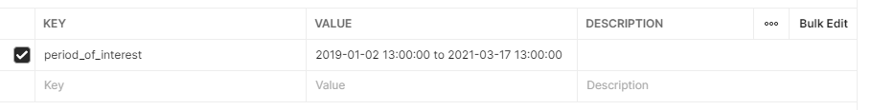
Test output
Same as above
Success

Unit Test6

Corresponding to 2 precise times (reverse order)
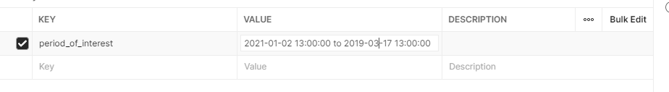

Test output
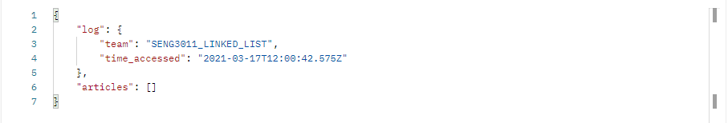
Success but no information, an error should be reported

Unit Test7

Corresponds to 2 precise times, but the time is wrong
Test Input
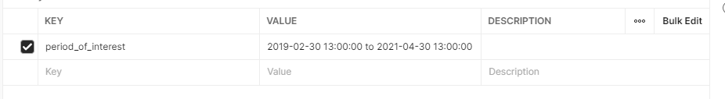
output
Same like Unit Test4
But an error should be reported because the time does not meet the requirements.

Unit Test8
Corresponds to 2 precise times, the first time is wrong
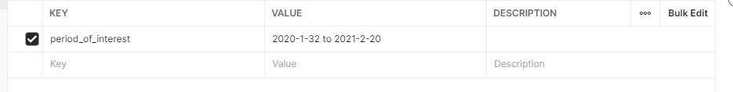

output
{
"errorMessage": "400 'start_date' is an invalid date format"
}

Success

Unit Test8
Corresponds to 2 precise times, the second time is wrong
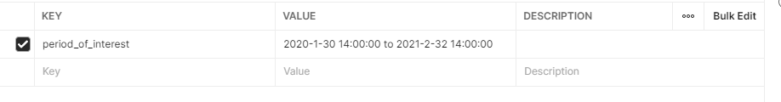
output

{
"errorMessage": "400 'end_date' is an invalid date format"
}

Success

Unit Test9
Corresponds to 2 precise times, ignoring hours
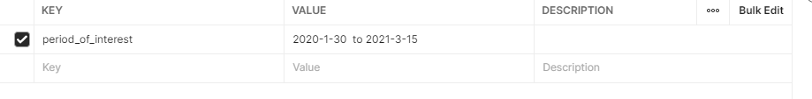
output
Same like Unit Test4

Maybe Success?Check the log

Unit Test10

Extremely close time
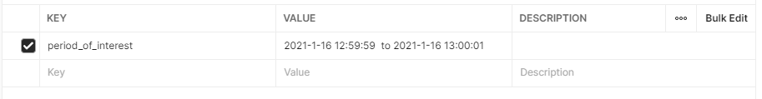
output
Same like Unit Test 1
Success

Unit Test11

Same time
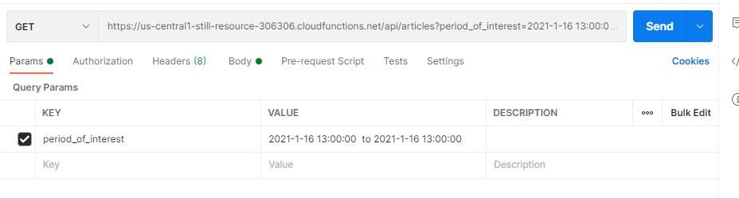

output
Same like Unit Test1
Success

Unit Test12

Add the normal Test -cov of key_term
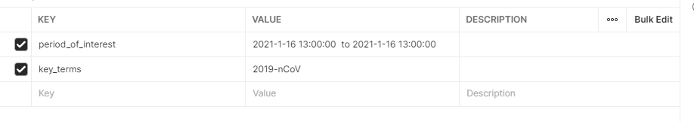

Same like Unit Test1
Success

Unit Test13

Abnormal Test-cov with key_term added
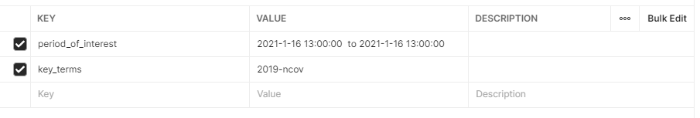

Same like Unit Test1
Success

Unit Test14

Add the normal Test wuhan of key_term
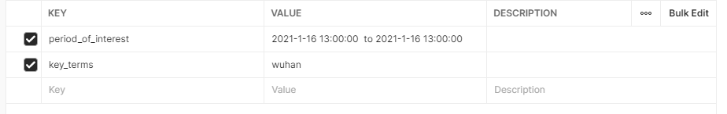

Same like Unit Test1
Success

Unit Test15

Add key_term's normal Test Fever of unknown Origin
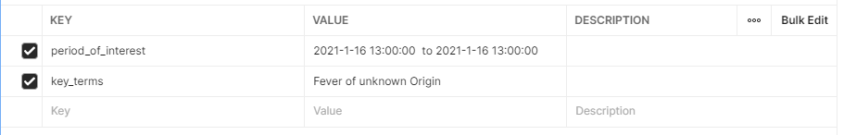
Same like Unit Test1
Success

Unit Test16
Normal Test fever with key_term added
Same like Unit Test1
Success

Unit Test17
Add key_term abnormality Test silence wench
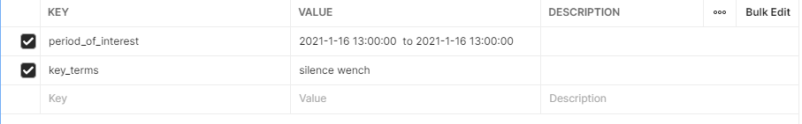

Testoutput
{
"log": {
"team": "SENG3011_LINKED_LIST",
"time_accessed": "2021-03-17T12:18:42.811Z"
},
"articles": []
}

Maybe it should return an error response that no information was found, but 200 was returned
May 400

Unit Test18

Can the test recognize similar diseases -covid-19
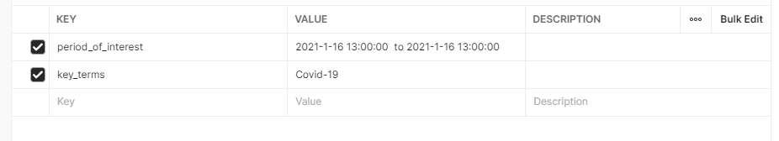
Test output
{
"log": {
"team": "SENG3011_LINKED_LIST",
"time_accessed": "2021-03-17T12:19:53.193Z"
},
"articles": []
}

It seems that there is no such function

